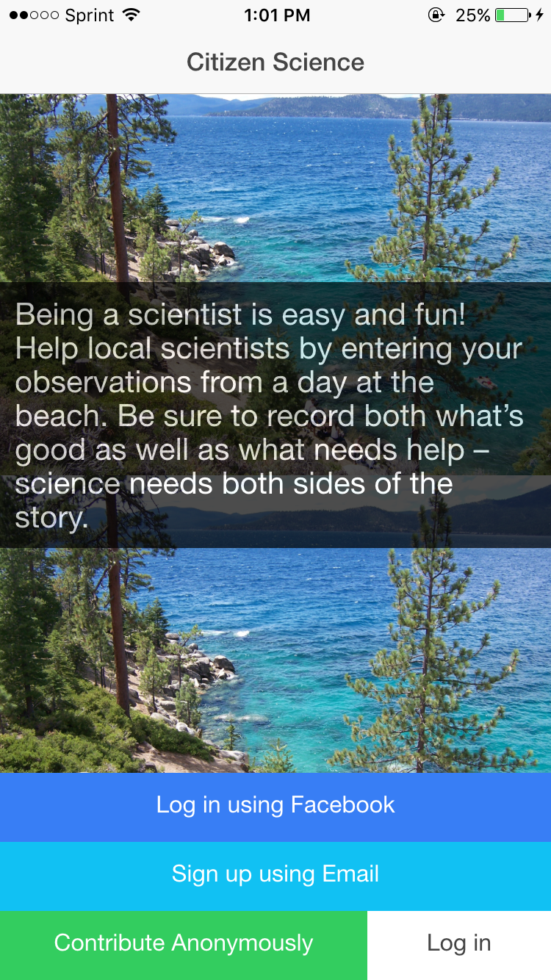

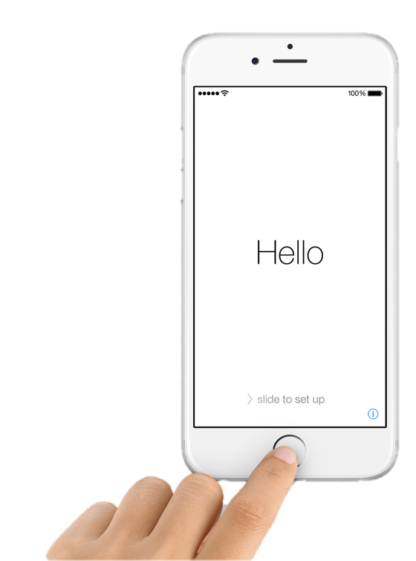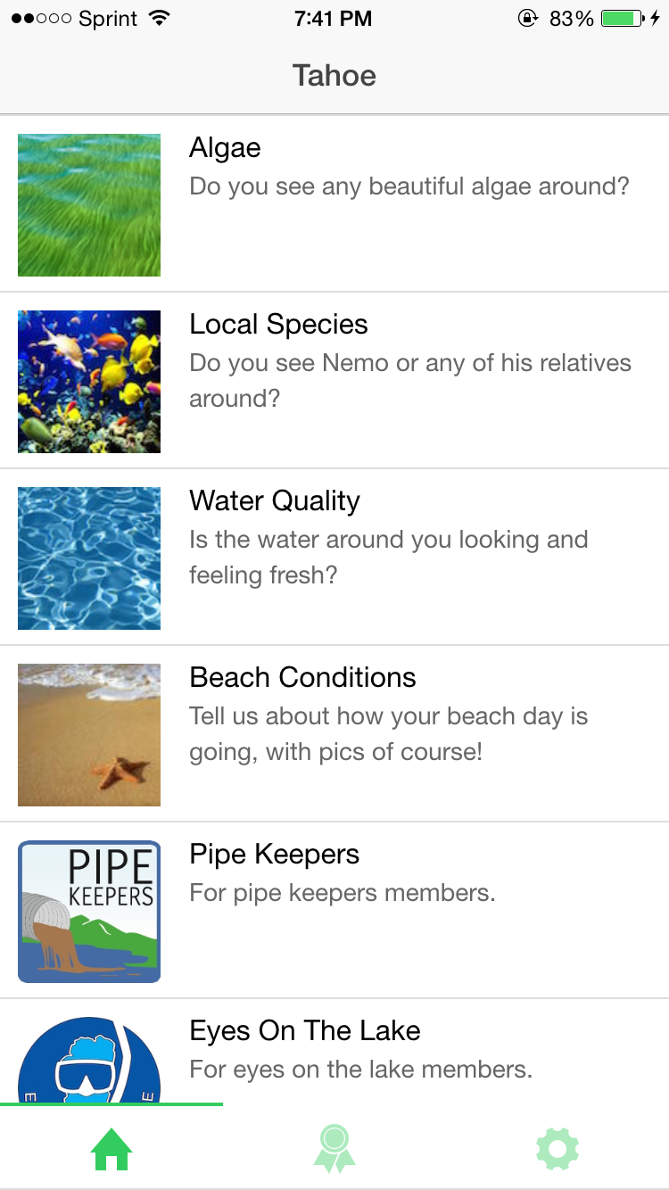

User Sign Up

Users can choose to sign up using Facebook, sign up using email, or contribute anonymously.

The Log in button is for users who signed up using email.

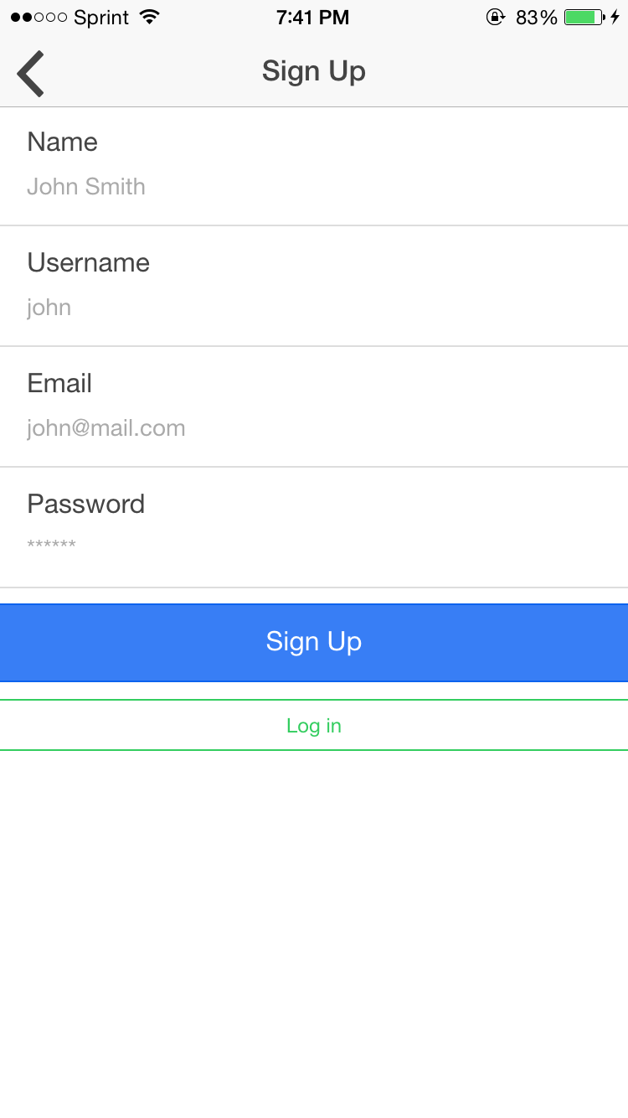

User’s can sign up using their email addresses here.

A convenient Log in button takes the users to the next screen

User Sign Up

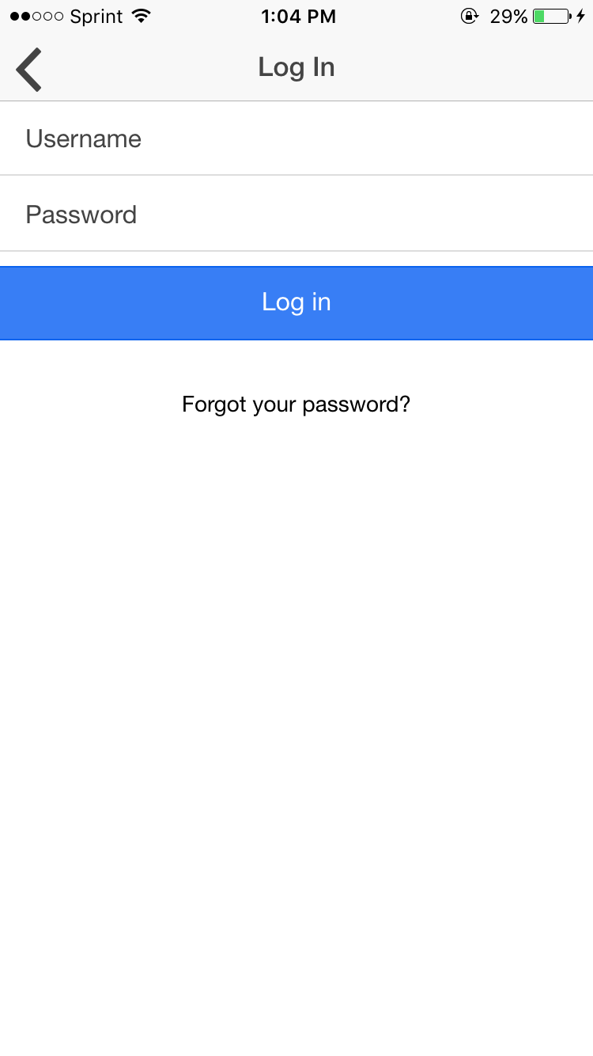

Users who log in via email can Log in here.

Forgotten password button will allow users to recover their passwords.

User Log In

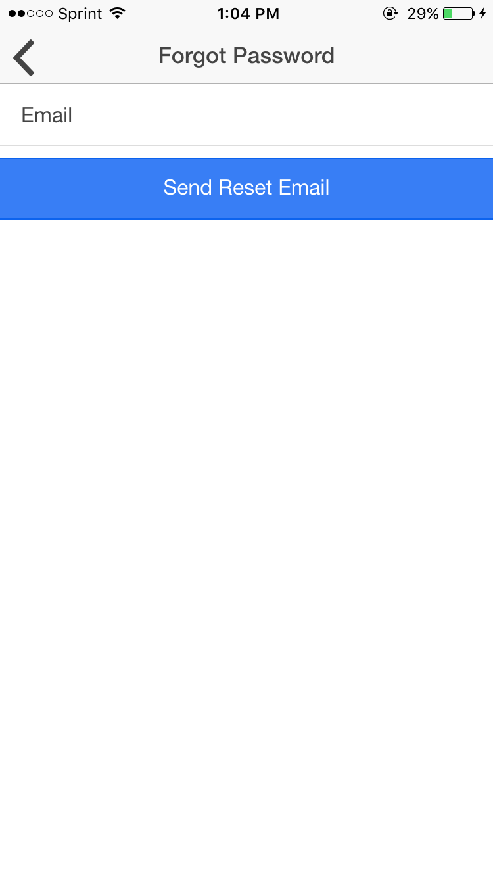

User Forgotten Password

A password recovery link will be sent to the users email.

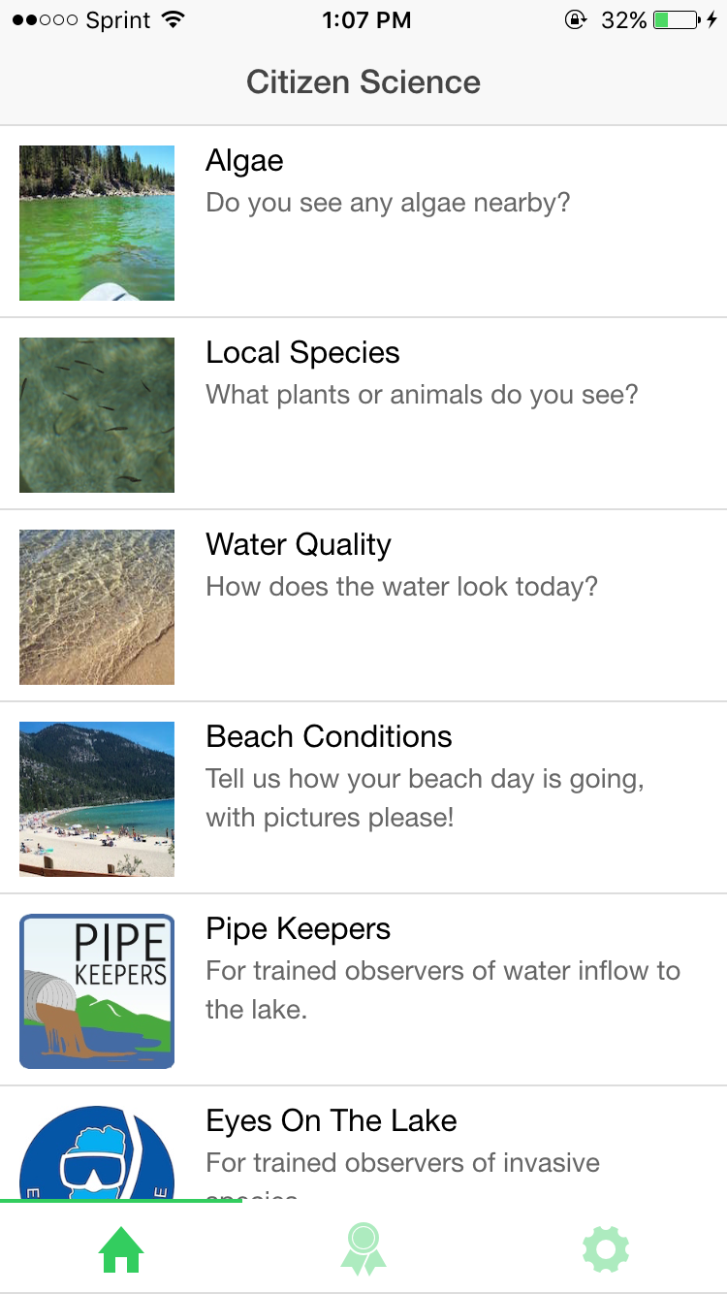

Main Home Tab

Users are led to this page after they have chosen their method of authentication.

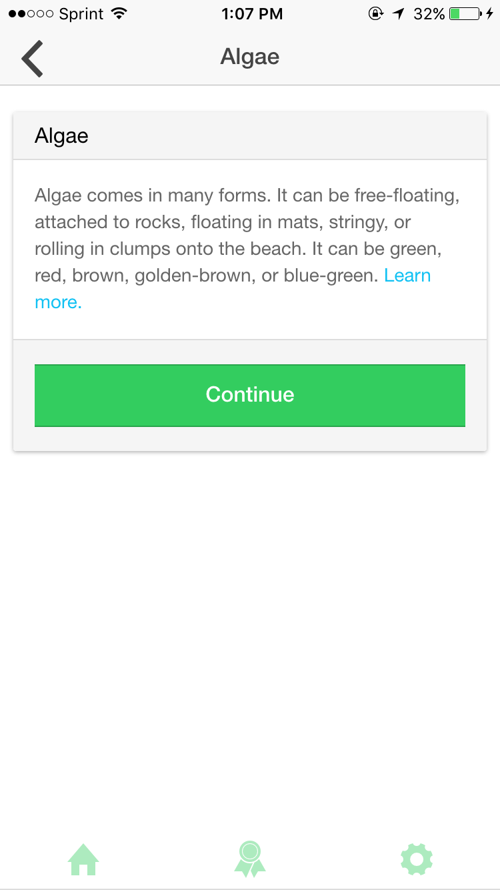

A brief introduction is shown to users when they click on the first 4 items on the Main Home Page.

Clicking Continue causes the next screen to appear.

Main Algae

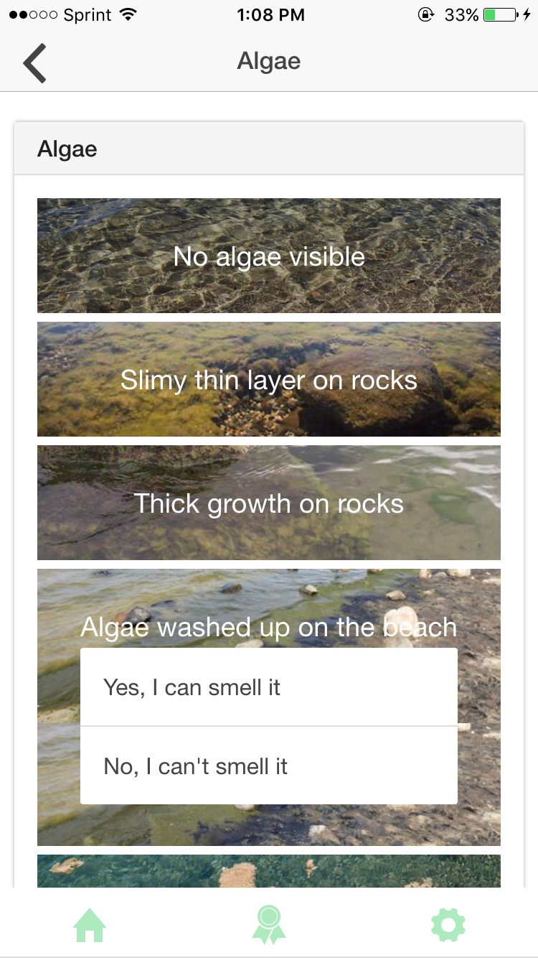

Allows the user to make observations.

Observation Algae

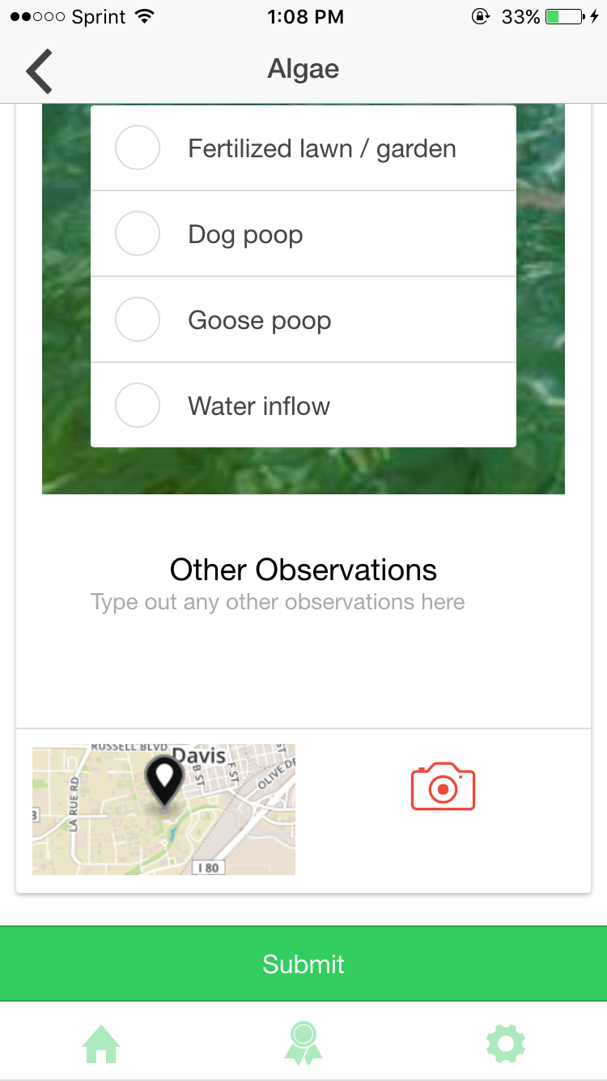

Observation Algae

Mini map is populated with the users current location.

Red *camera* button opens the camera on the next screen.

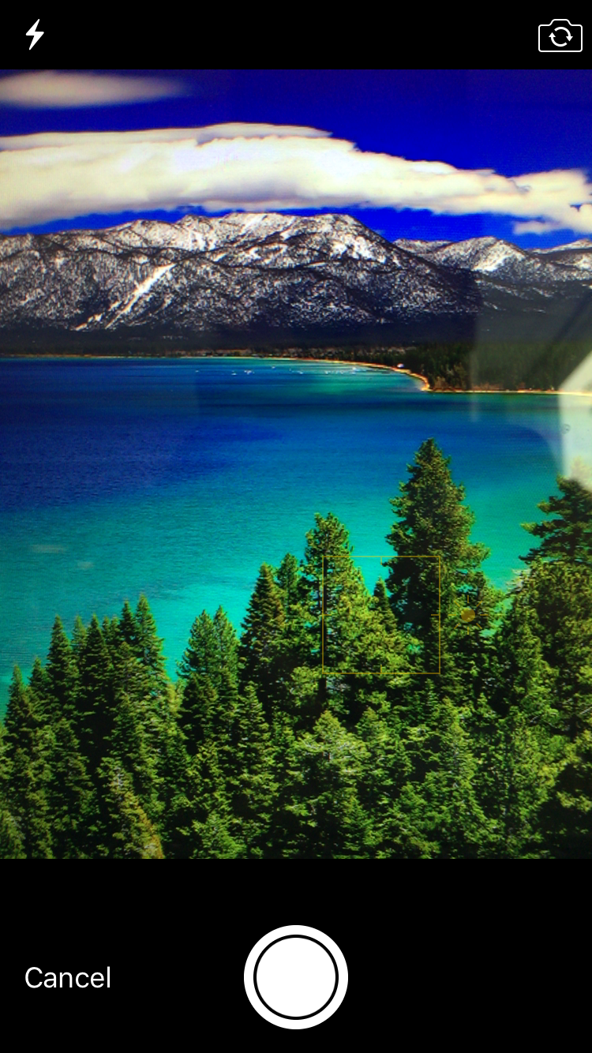

Camera is armed and ready to take a picture.

Taking a picture leads to the next screen.

Camera Algae

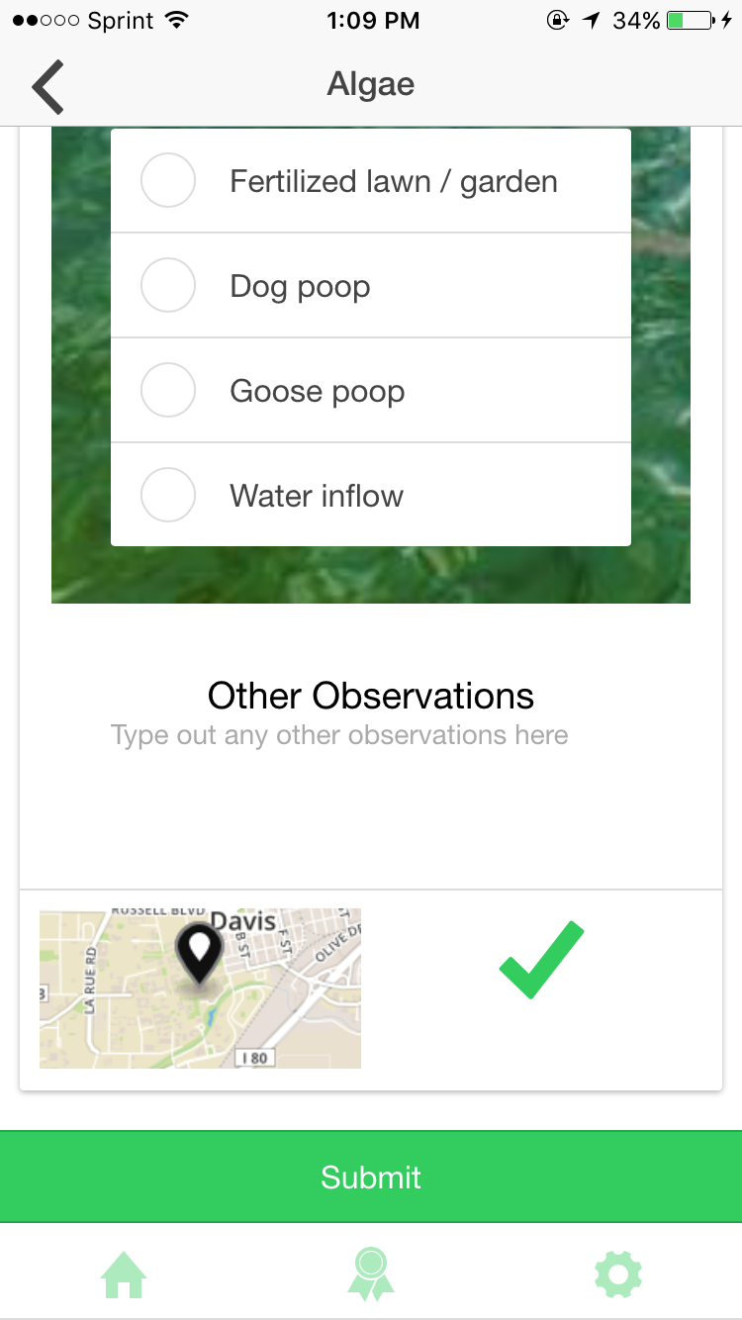

Observation Algae

When the desired data has been put in, the location has been enabled, and a photo has been taken, the user is ready to *Submit* the data.

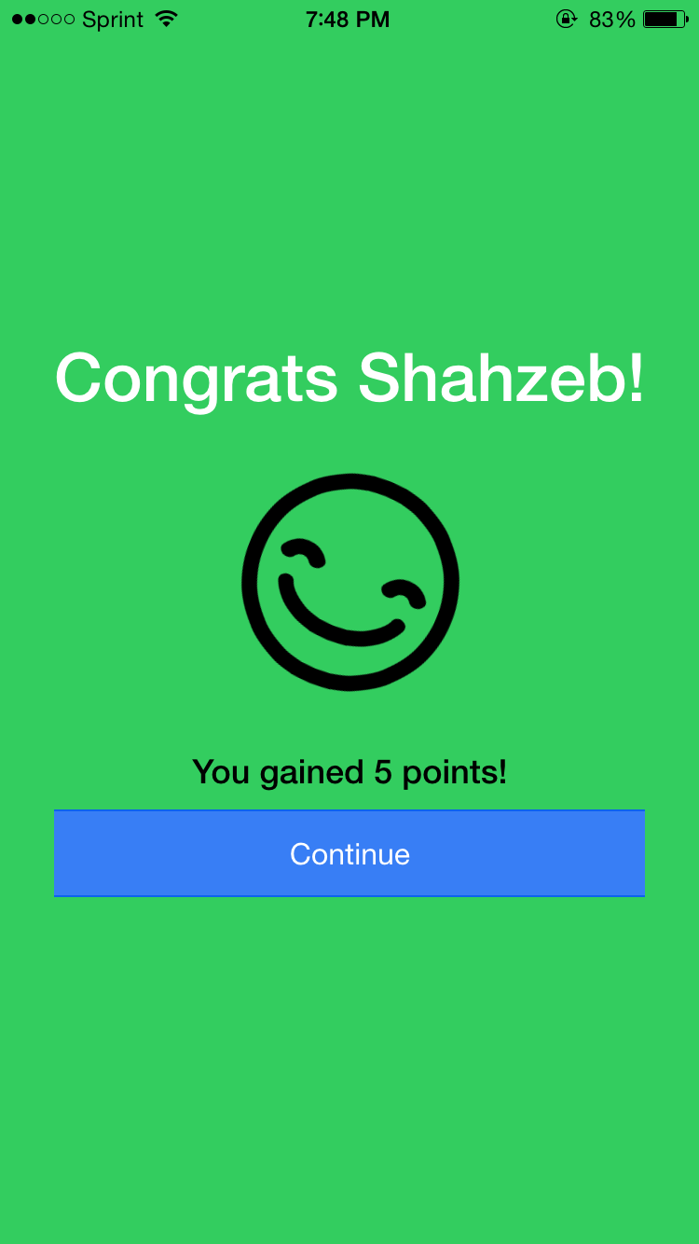

When the desired data has successfully been submitted.

Points:

+5 data

+5 location

+5 photo

Continue button takes user to *Main Home Tab*.

Successful Algae

Algae, Local Species, Water Quality & Beach Condition all follow similar

routines when it comes to inputting data.

\*

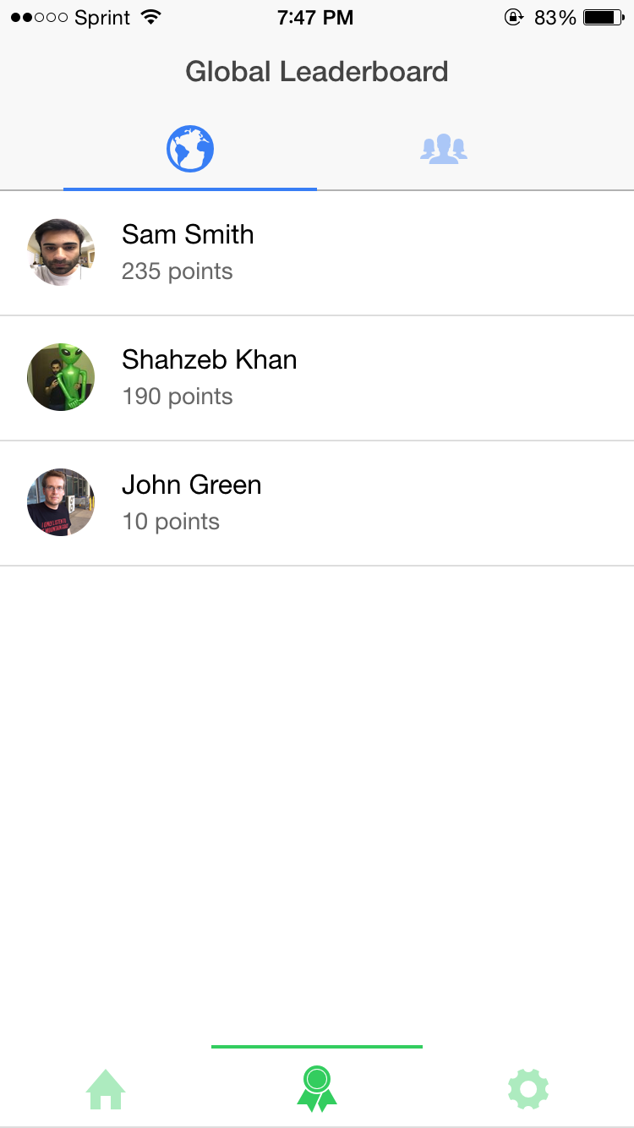

Global leaderboard (indicated by the *blue globe tab* on the top bar) arranges everyone by the earned points.

Global Leaderboard

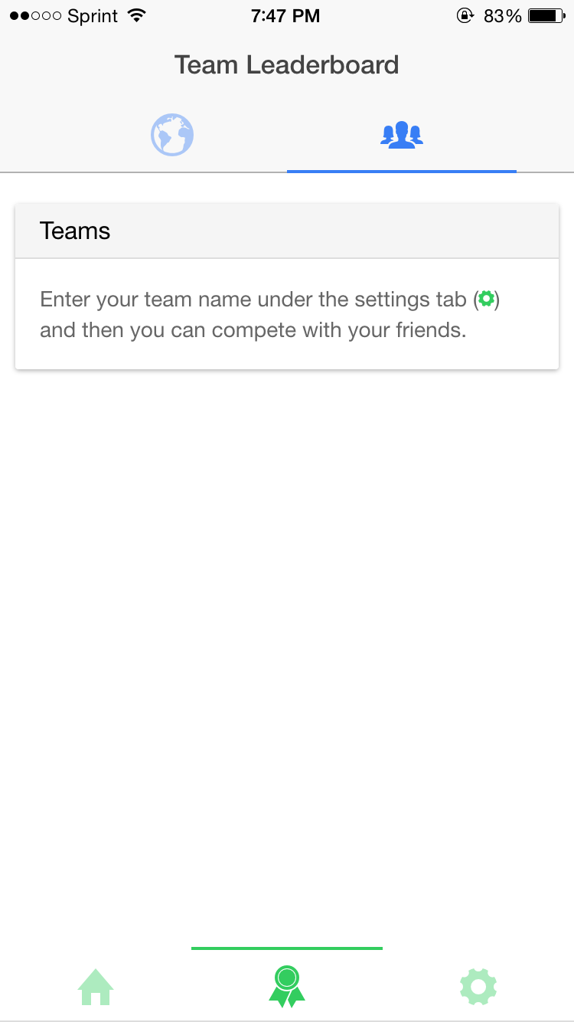

Team leaderboard (indicated by the blue *team icon* on the top bar).

Finds users with the same team name, and arranges them by points.

Team Leaderboard

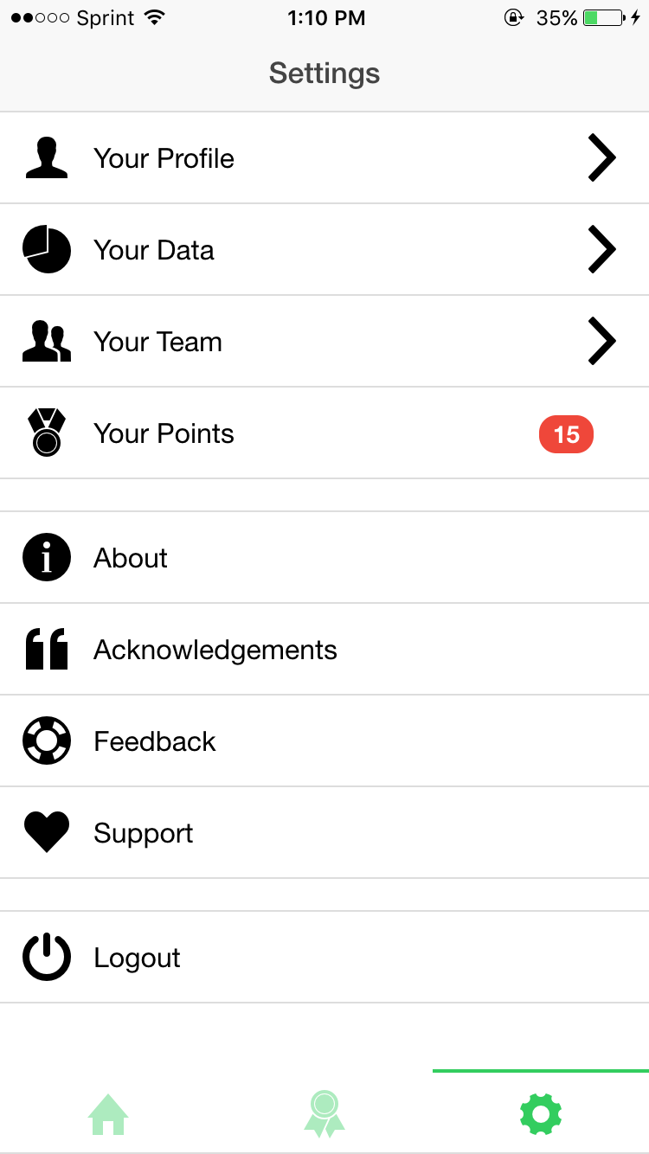

Main Settings

The main settings tab.

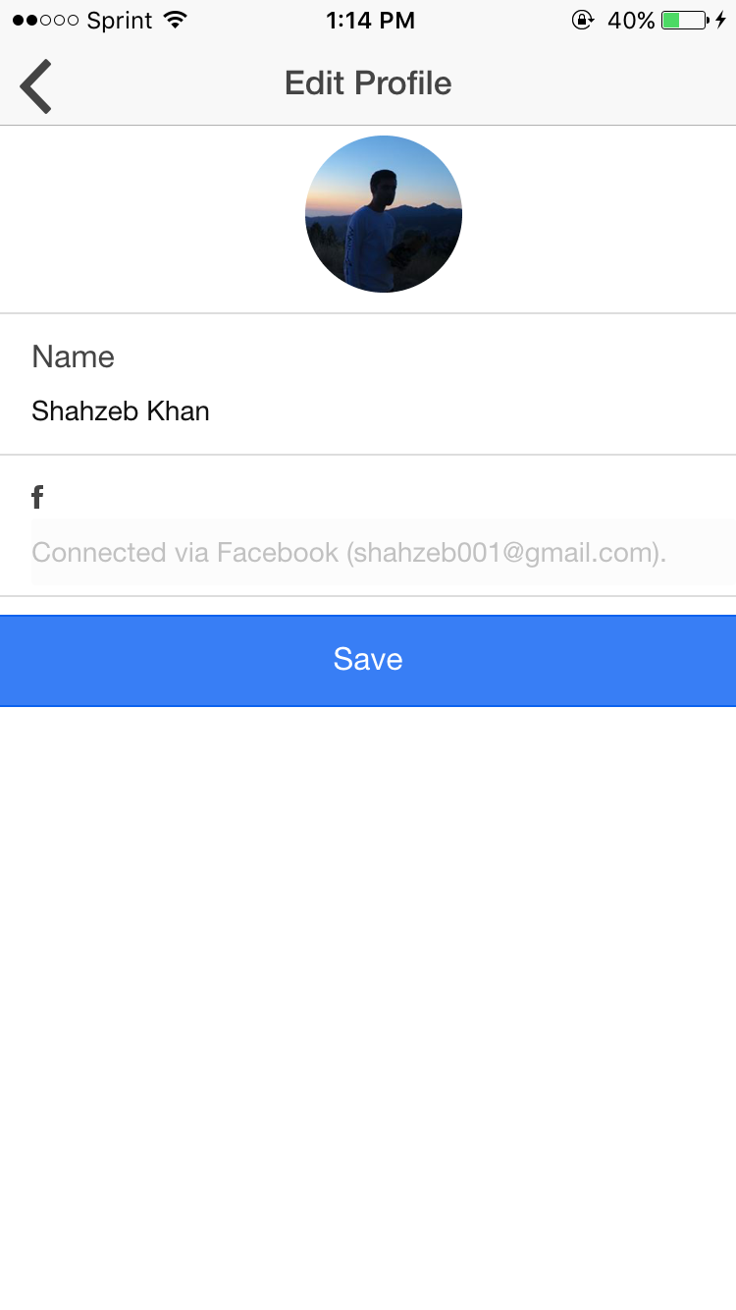

Profile Settings

Allows the user to edit various aspects of their profile.

If you are not logged in with Facebook then you can edit your email and change your profile picture.

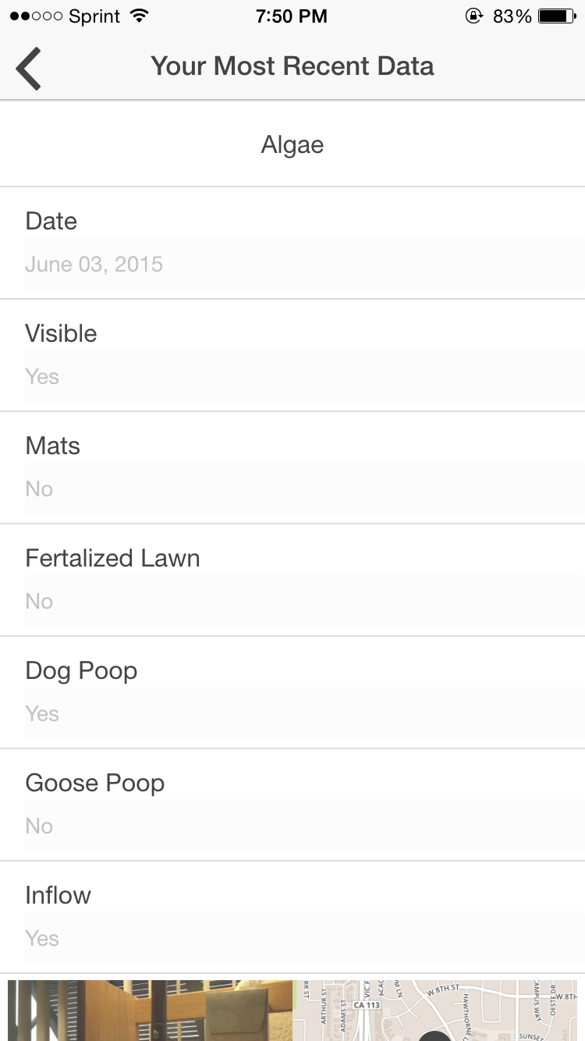

Main Data

Shows the users most recent data.

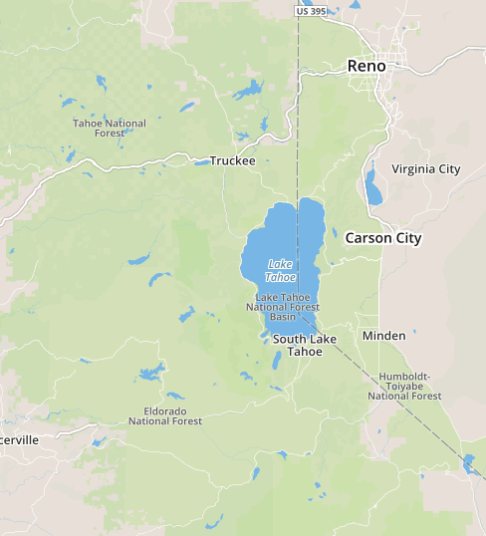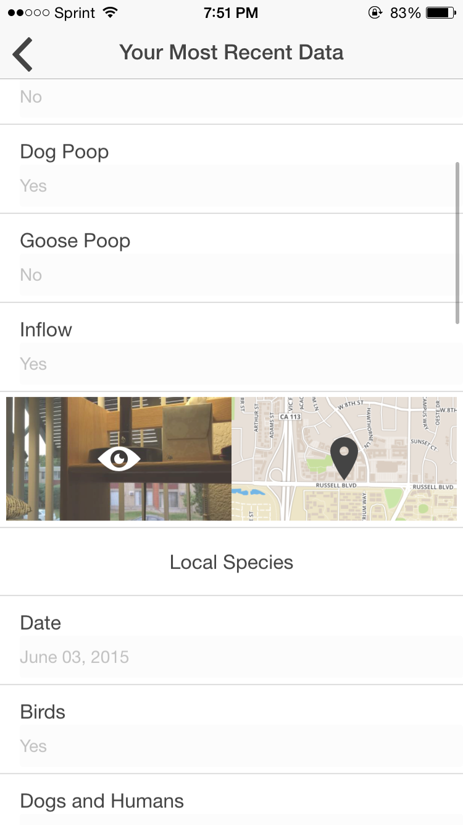

Main Data

Users can scroll down and view their submitted images and locations.

Clicking on the submitted image or location leads to the next 2 screens.



Image Data

Clicking on an image the user submitted allows the user to view the image.

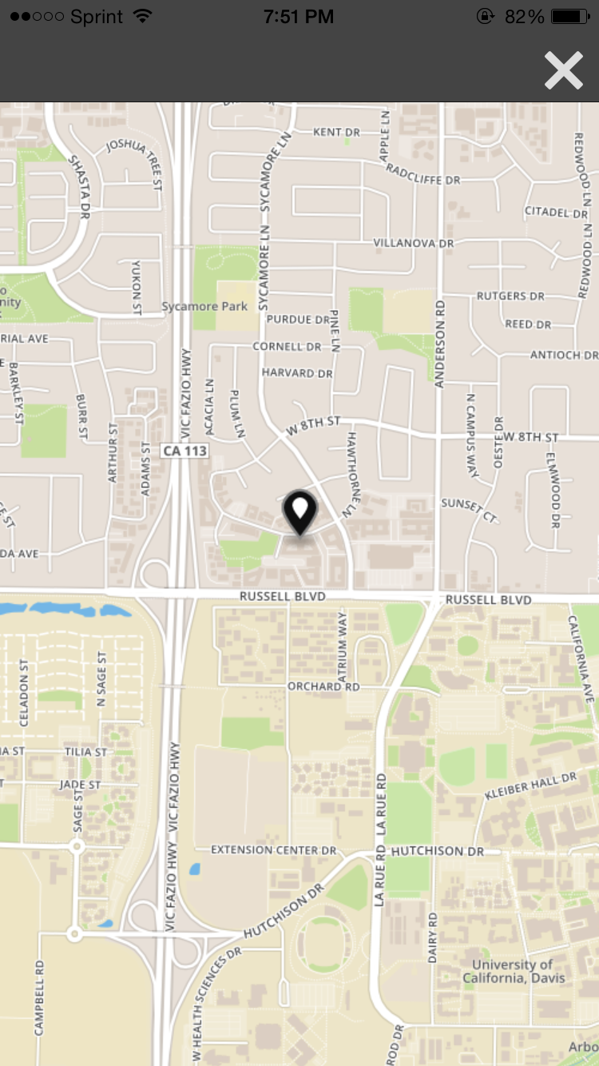

Clicking on the map reveals a static map for the coordinates that the user submitted.

Map Data

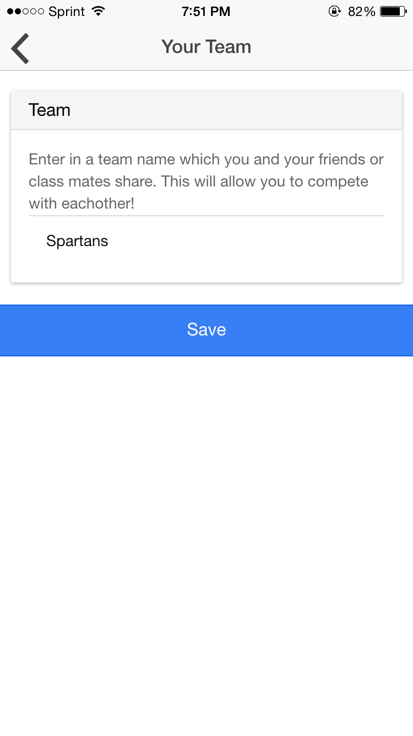

Allows the user to enter in their desired team name.

The input is not case sensitive so anyone who enters “Aggies” or “aggies” will end up on the same team. Avoids potential future confusion.

Team Settings



About the app.

About Settings



An easy way to email the developer with any questions or feedback.

Contact Settings



A screen displaying a list of people involved in the project along with other credits.

Acknowledgements

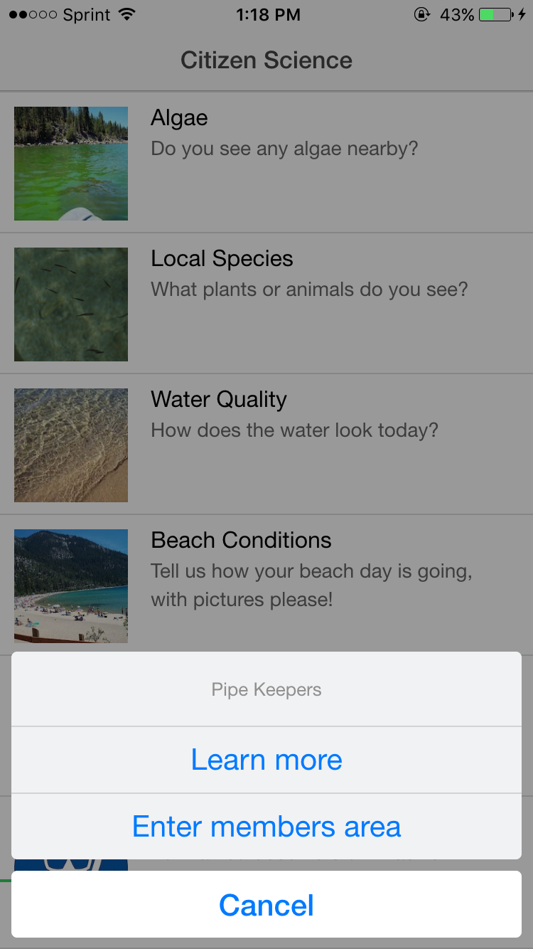

Pipe Keepers

Clicking on Pipe Cleaners reveals a *Learn more* option (which takes the user to the official Pipe Cleaners website)

And an *Enter members area* option which allows users to enter their password and gain access to the upcoming screens.

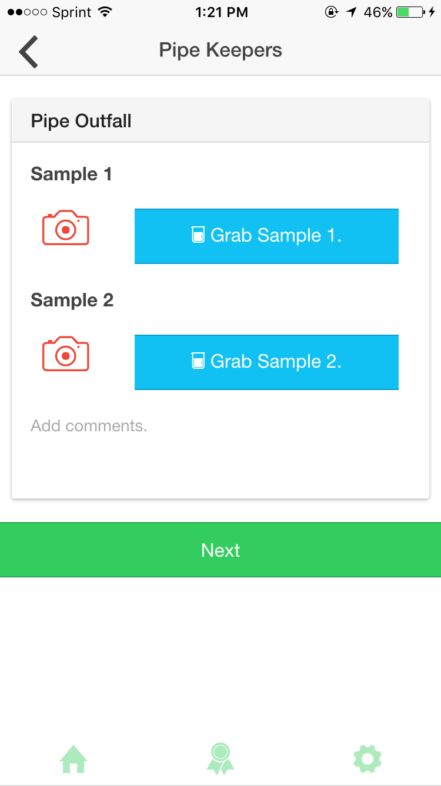

Pipe Keepers

Data entry page for Pipe Keepers.

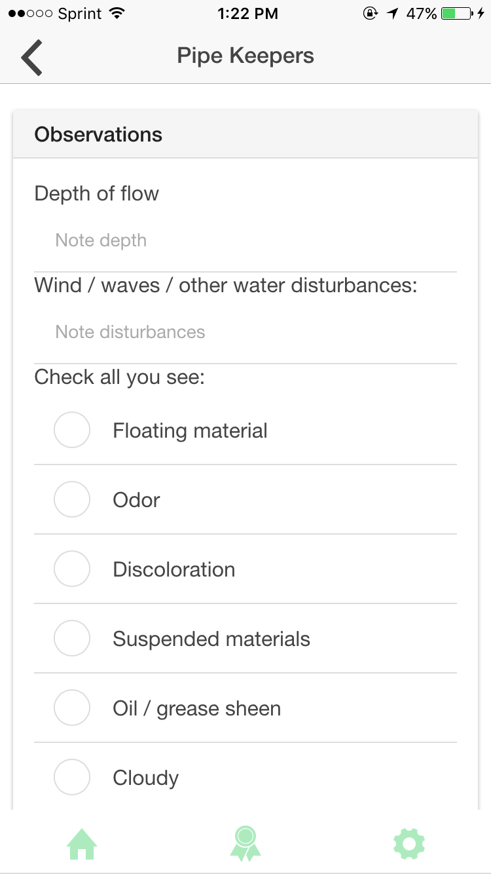

Ability to add more observations for Pipe Keepers.

Pipe Keepers

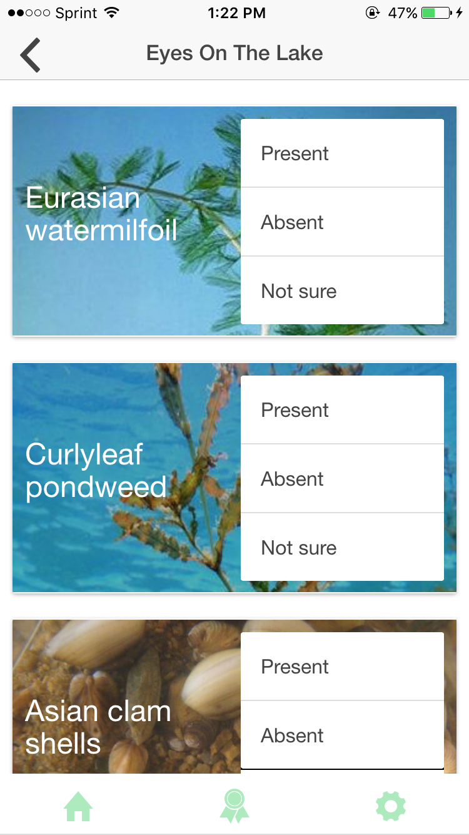

Users can make observations.  
  
Selecting “*Present*” and “*Not sure*” leads to the upcoming screen.

Eyes On The Lake

c

Eyes On The Lake

More options are displayed when “*Present”* or *“Not sure”* is selected.

Both Pipe Keepers & Eyes The Lake are smart in the sense that the user only enters the password for the members area once.

\*

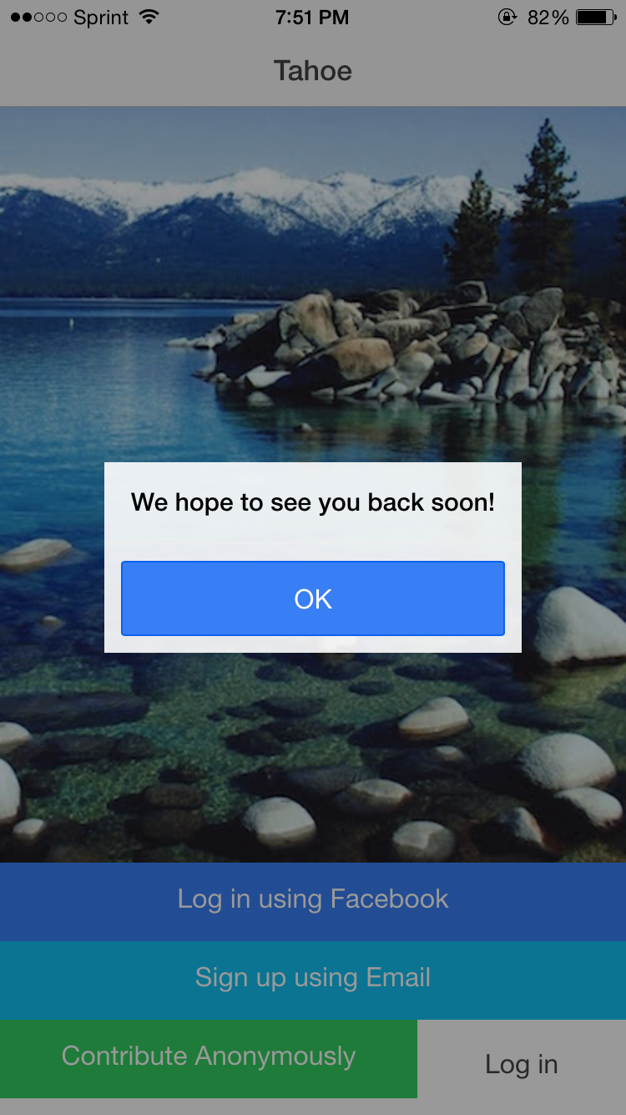

Logging Out

*fin*.